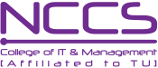

Studnets ID CARD

**National College of Computer Studies(NCCS)**

**Paknajol,Kathmandu**





**SIGNATURE**

Name: Sahil Adhikari

Adress:Tokha, Kathmandu

Father name:Sabuj Adhikari

Phone no:9845…….

Email:saelad24@gmail.com

Semister:1st

Faculty:BIM

**CONTACT NO:01-8537282**

**CONATACT NO:01-4345678**